Fig 1:

- Flowchart of the proposed weapon detection model (Training Mode)

dfsdfsdfsdvxcvxcvxcvx

Calculate the average image dimensions
One-Class Dataset
Train YOLOv5s (RoI Detector)
1st stage training weights file
Validate training & calculate metrics
Train ResNet-101 Classifier
Aligned objects’ images
RoIAlign of object images
Final output: two stages training weights
Extract original bbox around objects
Object images of various sizes
2nd stage training weights file
Multi-Class Dataset
Validate training & calculate metrics

Fig 2:

- Flowchart of the proposed weapon detection model (Detection Mode)

No
Yes
Input Image
YOLOv5s (RoI Detector)
bbox around objects
RoIAlign of object images
ResNet-101 Classifier
Aligned objects’ images
K-means (bbox refiner)
Refined bbox around objects
Weapon?
Labeled and localized weapon

Fig 3:
- Model Structure a. model structure in the training phase b. model structure in the detection phase
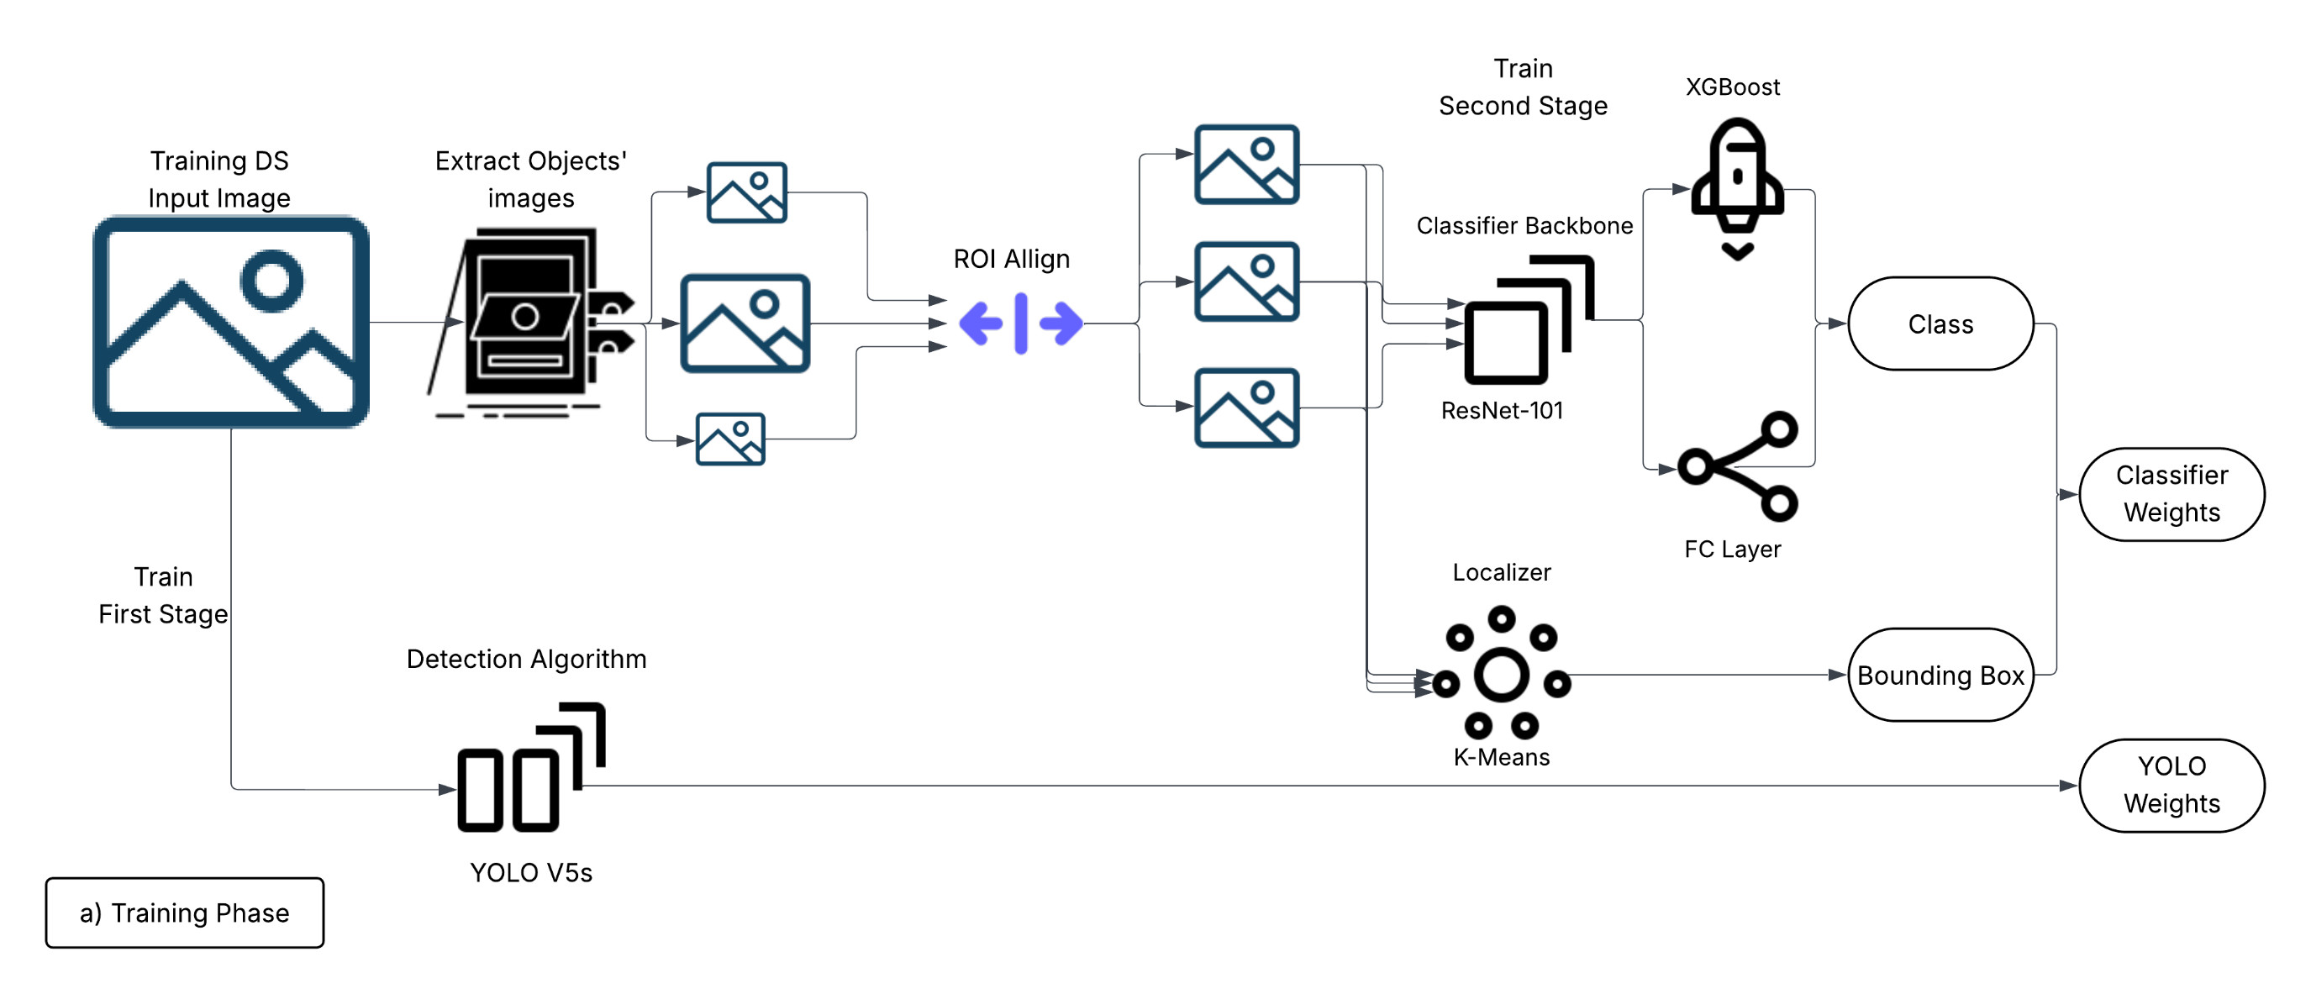
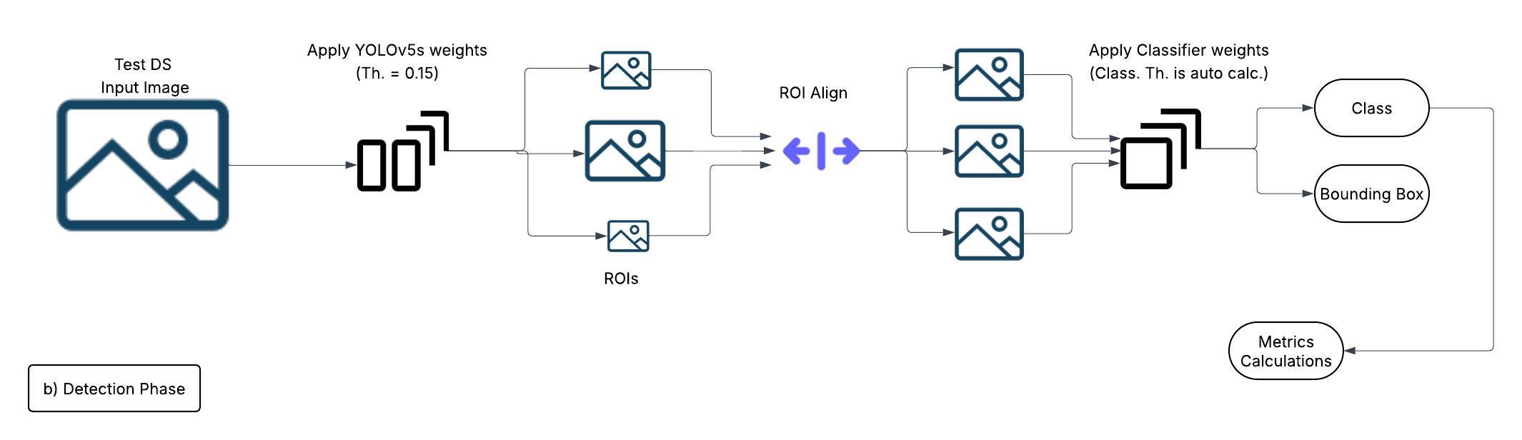

Fig 4:

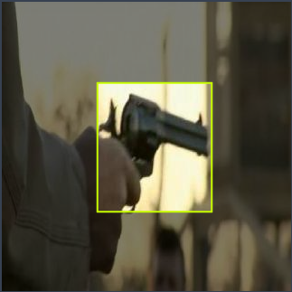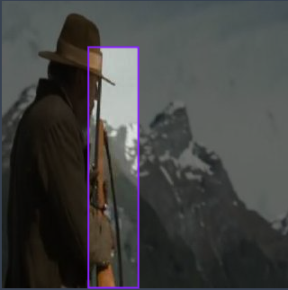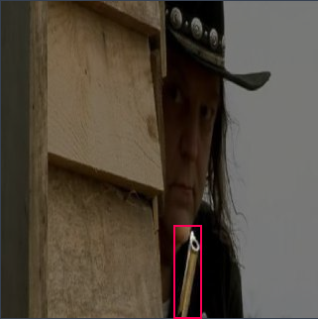
- Three sample images from the proposed Weapon dataset, representing classes (“Gun”, “LongGun”, “PartialGun”) respectively

Fig 5:

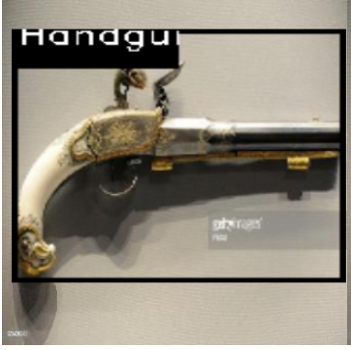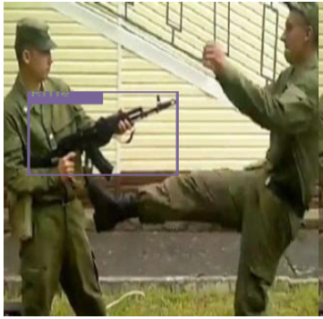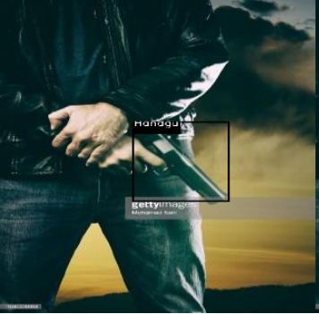

- Three sample images from the Weapon Classification reference dataset, representing classes (“Handgun”, “Rifle”, “Handgun”) respectively

Fig 6:

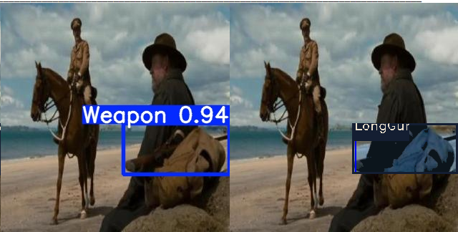 | LongGun
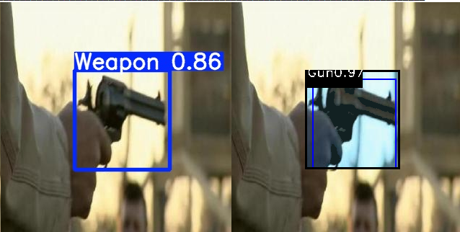 | Gun  with improved localization
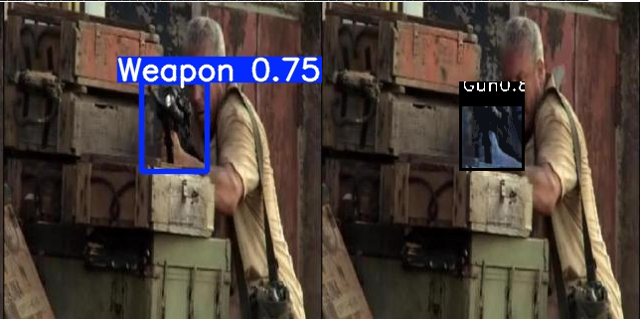 | Weapon with misclassification by the 2nd stage
- Sample detections with re-localization
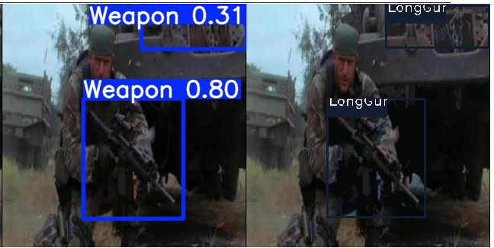 | FP by the 1st stage, propagates to the 2nd stage
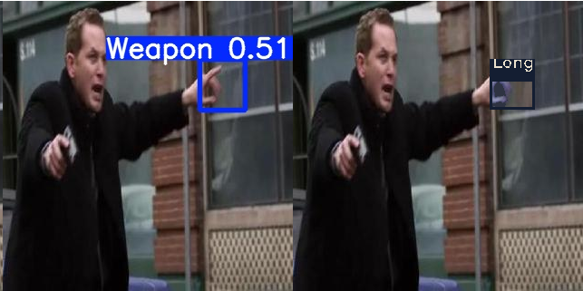 | Missing by the 1st stage, and a FP propagation
- Sample error patterns
- Sample detections and error patterns of the proposed model on the proposed Weapon dataset, assuming any misclassification is counted as a weapon hit rather than a miss

Fig. 7

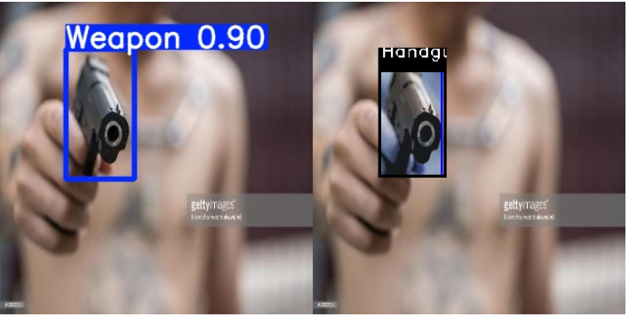 | Handgun
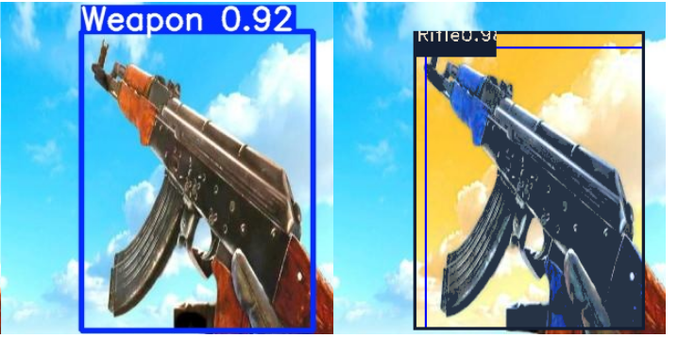 | Rifle  with improved localization
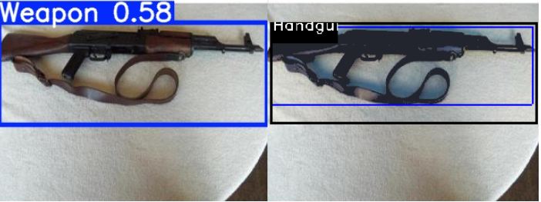 | Weapon with misclassification by the 2nd stage.
- Sample detections with re-localization
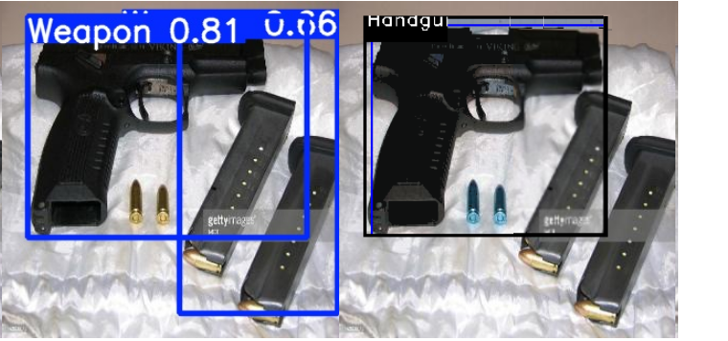 | FP by the 1st stage, corrected by the 2nd stage (becomes a true negative)
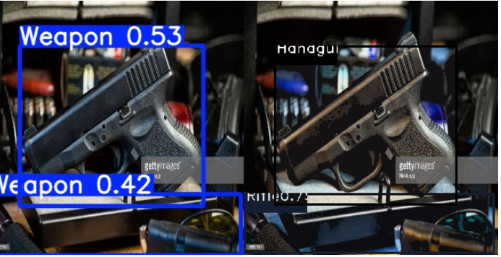 | FP by the 1st stage, propagates to the 2nd stage.
- Sample error patterns
- Sample detection and error patterns of the proposed model on the Weapon Classification reference dataset

Fig. 8

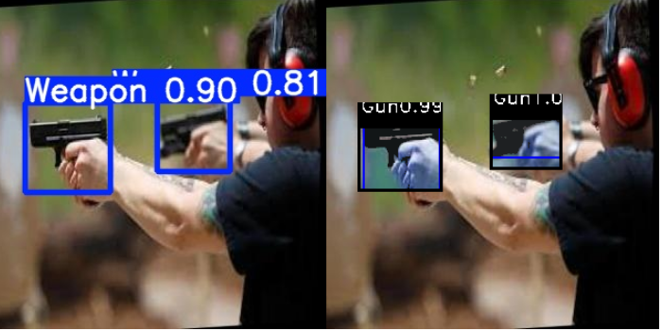 | Gun
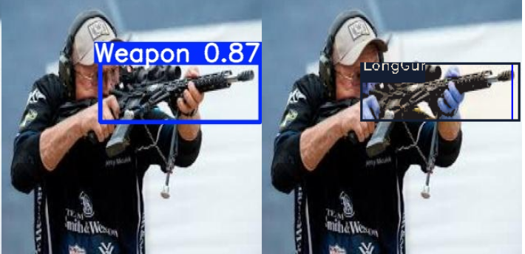 | LongGun
- Sample detections with re-localization
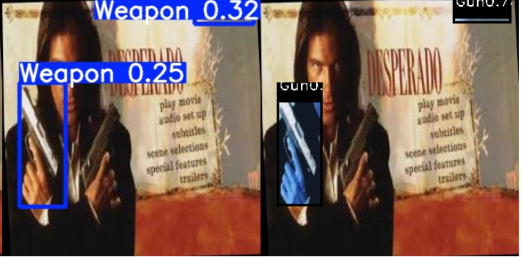 | Missing by the 1st stage and false-positive propagation
- Sample error patterns
- Sample detection and error patternsof the proposed model on unseen footage, Y1 dataset

Fig. 9

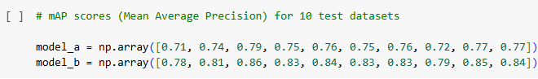
- Two models’ mAP arrays across ten different datasets
- p-value results of the Shapiro-Wilk test for data normality
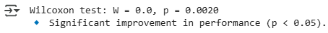
- Output of the selected p-value test (Wilcoxon test)
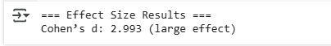
- Output of the selected effect size test (Cohen’s d)
- Statistical test results show that a significant improvement is achieved by using the proposed model

